

Practical No.: 7
Aim –
Perform DOM traversal and updates; develop a To-Do List application with add, edit, and delete features. Implement a registration form using JavaScript event handling and form validation.
Software/Tools Required –
VSCode, Chrome, HTML5, CSS3, Javascript (ES6)
Experiment Program Code –
index.html
<!DOCTYPE html>
<html lang="en">

<head>
<meta charset="UTF-8">
<meta name="viewport" content="width=device-width, initial-scale=1.0">

<title>My To-Do List</title>

<style>

* {
margin: 0;
padding: 0;
box-sizing: border-box;
}

body {
min-height: 100vh;
font-family: "Segoe UI", Arial, sans-serif;

display: flex;
justify-content: center;
align-items: center;

padding: 30px;

background:
radial-gradient(circle at top left, #f9d6e6, transparent 35%),
radial-gradient(circle at bottom right, #d9d3ff, transparent 40%),
linear-gradient(135deg, #fff8fc, #f3f0ff);
}

.container {
width: 100%;
max-width: 520px;

padding: 35px;

border-radius: 28px;

background: rgba(255, 255, 255, 0.88);

backdrop-filter: blur(12px);

box-shadow:
0 20px 60px rgba(105, 82, 140, 0.18);
}

/* Header */

.header {
text-align: center;
margin-bottom: 30px;
}

.icon {
width: 58px;
height: 58px;

margin: 0 auto 15px;

display: flex;
align-items: center;
justify-content: center;

border-radius: 18px;

font-size: 25px;

background:
linear-gradient(135deg, #c7b8ff, #f4b8d5);

box-shadow:
0 8px 20px rgba(170, 140, 200, 0.25);
}

.header h2 {
color: #4d4261;
font-size: 30px;
margin-bottom: 7px;
}

.header p {
color: #91869e;
font-size: 14px;
}

/* Input Area */

.input-area {
display: flex;
gap: 10px;
}

#taskInput {
flex: 1;

padding: 14px 16px;

border: 1.5px solid #e6dff0;

border-radius: 14px;

background: #fcfaff;

outline: none;

font-size: 14px;

transition: 0.3s;
}

#taskInput:focus {
border-color: #ae9bea;

box-shadow:
0 0 0 4px rgba(174, 155, 234, 0.15);
}

#addBtn {
padding: 12px 20px;

border: none;
border-radius: 14px;

cursor: pointer;

color: white;

font-size: 14px;
font-weight: 600;

background:
linear-gradient(135deg, #9b8bd7, #d98eb5);

box-shadow:
0 8px 18px rgba(180, 130, 180, 0.25);

transition: 0.3s;
}

#addBtn:hover {
transform: translateY(-2px);

box-shadow:
0 12px 22px rgba(180, 130, 180, 0.3);
}

/* Tasks Heading */

.task-title {
display: flex;
justify-content: space-between;
align-items: center;

margin: 28px 0 15px;
}

.task-title h3 {
color: #5c526b;
font-size: 16px;
}

.task-title span {
padding: 5px 11px;

border-radius: 20px;

background: #f2edff;

color: #927fca;

font-size: 12px;
}

/* Task List */

ul {
list-style: none;
}

li {
display: flex;
justify-content: space-between;
align-items: center;

margin-bottom: 12px;

padding: 14px 15px;

border-radius: 16px;

background:
linear-gradient(135deg, #ffffff, #faf7ff);

border: 1px solid #eee8f5;

box-shadow:
0 5px 15px rgba(80, 60, 110, 0.06);

animation: appear 0.35s ease;
}

li span {
flex: 1;

color: #5b5265;

font-size: 14px;

word-break: break-word;

padding-right: 10px;
}

/* Buttons */

.buttons {
display: flex;
gap: 7px;
}

.buttons button {
border: none;

padding: 7px 11px;

border-radius: 9px;

cursor: pointer;

color: white;

font-size: 12px;

transition: 0.25s;
}

.edit {
background:
linear-gradient(135deg, #f0ae72, #e990a7);
}

.delete {
background:
linear-gradient(135deg, #dc7c91, #c96078);
}

.buttons button:hover {
transform: translateY(-2px);
}

/* Footer */

.designer {
margin-top: 28px;
padding-top: 18px;

border-top: 1px solid #eee8f2;

text-align: center;

color: #aaa0b0;

font-size: 11px;

line-height: 1.8;
}

.designer strong {
color: #8d78b9;
}

/* Animation */

@keyframes appear {

from {
opacity: 0;
transform: translateY(10px);
}

to {
opacity: 1;
transform: translateY(0);
}

}

/* Mobile */

@media (max-width: 500px) {

.container {
padding: 28px 20px;
}

.input-area {
flex-direction: column;
}

#addBtn {
width: 100%;
}

li {
flex-direction: column;
align-items: flex-start;
}

.buttons {
margin-top: 5px;
}

}

</style>

</head>

<body>

<div class="container">

<div class="header">

<div class="icon">
✓
</div>

<h2>My To-Do List</h2>

<p>
Little tasks. Big progress. ✦
</p>

</div>

<div class="input-area">

<input
type="text"
id="taskInput"
placeholder="What would you like to do?"
>

<button id="addBtn">
+ Add
</button>

</div>

<div class="task-title">

<h3>
Today's Tasks
</h3>

<span>
Stay productive ✦
</span>

</div>

<ul id="taskList"></ul>

<div class="designer">

Designed by
<strong>Sanskruti Gorle</strong>

<br>

PRN:
<strong>24070521025</strong>

</div>

</div>

<!-- YOUR ORIGINAL JAVASCRIPT -->

<script>

const taskInput = document.getElementById('taskInput');
const addBtn = document.getElementById('addBtn');
const taskList = document.getElementById('taskList');

addBtn.addEventListener('click', function() {
let task = taskInput.value.trim();

if (task === ""){
alert("Please enter a task!");
return;
}

const li = document.createElement('li');
const span = document.createElement('span');
span.textContent = task;

const buttons = document.createElement('div');
buttons.className = 'buttons';

const editBtn = document.createElement('button');
editBtn.textContent = 'Edit';
editBtn.className = 'edit';

editBtn.addEventListener('click', function() {
let newTask = prompt("Edit your task:", span.textContent);
if (newTask !== null && newTask.trim() !== "") {
span.textContent = newTask;
}
});

const deleteBtn = document.createElement('button');
deleteBtn.textContent = 'Delete';
deleteBtn.className = 'delete';

deleteBtn.addEventListener('click', function() {
taskList.removeChild(li);
});

buttons.appendChild(editBtn);
buttons.appendChild(deleteBtn);

li.appendChild(span);
li.appendChild(buttons);
taskList.appendChild(li);

taskInput.value = "";
});

</script>

</body>

</html>

Output –
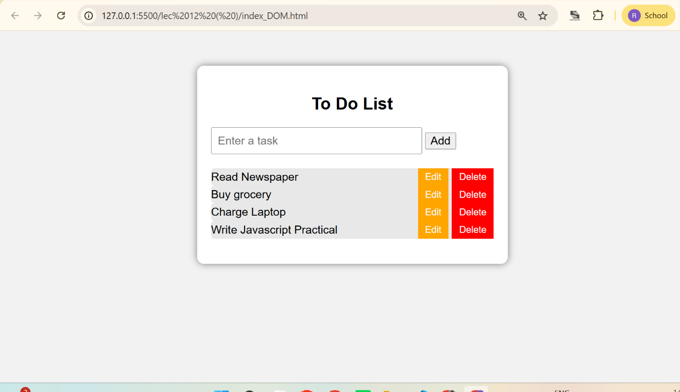

Case Study Title –
Implement a registration form using JavaScript event handling and form validation.
Case Study Program Code –
index.html
<!DOCTYPE html>
<html lang="en">
<head>
<meta charset="UTF-8">
<meta name="viewport" content="width=device-width, initial-scale=1.0">
<title>Registration / Sign Up Form</title>
<link rel="stylesheet" href="style.css">
</head>

<body>

<main class="page">
<section class="form-card">

<h1>Registration / Sign Up Form</h1>
<p class="subtitle">Create your account by filling in the details below</p>

<form id="registrationForm">

<div class="form-row">
<label for="firstname">Firstname <span>*</span></label>
<div class="field">
<input type="text" id="firstname" placeholder="Enter firstname">
<small class="error" id="firstnameError"></small>
</div>
</div>

<div class="form-row">
<label for="lastname">Lastname</label>
<div class="field">
<input type="text" id="lastname" placeholder="Enter lastname">
<small class="error" id="lastnameError"></small>
</div>
</div>

<div class="form-row">
<label>Birthday</label>
<div class="field">
<div class="birthday">
<select id="day">
<option value="">Day</option>
</select>

<select id="month">
<option value="">Month</option>
</select>

<select id="year">
<option value="">Year</option>
</select>
</div>

<small class="error" id="birthdayError"></small>
<small class="birthday-message" id="birthdayMessage"></small>
</div>
</div>

<div class="form-row">
<label for="username">Username <span>*</span></label>
<div class="field">
<input type="text" id="username" placeholder="Choose a username">
<small class="error" id="usernameError"></small>
</div>
</div>

<div class="form-row">
<label for="email">E-mail <span>*</span></label>
<div class="field">
<input type="email" id="email" placeholder="example@email.com">
<small class="error" id="emailError"></small>
</div>
</div>

<div class="form-row">
<label for="website">Website</label>
<div class="field">
<input type="text" id="website" placeholder="https://example.com">
<small class="error" id="websiteError"></small>
</div>
</div>

<div class="form-row">
<label for="password">Password <span>*</span></label>
<div class="field">
<input type="password" id="password" placeholder="Minimum 6 characters">
<small class="error" id="passwordError"></small>
</div>
</div>

<div class="form-row">
<label for="repassword">Re-password <span>*</span></label>
<div class="field">
<input type="password" id="repassword" placeholder="Re-enter password">
<small class="error" id="repasswordError"></small>
</div>
</div>

<div class="terms-row">
<input type="checkbox" id="terms">
<label for="terms">
I agree to the terms & conditions.
</label>
</div>

<small class="error terms-error" id="termsError"></small>

<button type="submit" id="signupBtn">Sign Up</button>

<p class="success" id="successMessage"></p>

</form>

</section>
</main>
<footer>
Designed by <strong>Rudrakshi Bhandekar</strong> |
PRN: <strong>24070521012</strong>
</footer>
<script src="script.js"></script>
</body>
</html>

Style.css
* {
margin: 0;
padding: 0;
box-sizing: border-box;
}

body {
font-family: "Segoe UI", Arial, sans-serif;
min-height: 100vh;
background: linear-gradient(135deg, #fff4ed, #f9e2d5, #fdf8f4);
color: #292321;
}

.page {
min-height: 100vh;
display: flex;
justify-content: center;
align-items: center;
padding: 35px 15px;
}

.form-card {
width: 630px;
background: rgba(255, 255, 255, 0.96);
padding: 35px 42px;
border-radius: 18px;
border: 1px solid #f0d7ca;
box-shadow: 0 15px 40px rgba(117, 67, 48, 0.13);
position: relative;
overflow: hidden;
}

.form-card::before {
content: "";
position: absolute;
top: 0;
left: 0;
width: 100%;
height: 6px;
background: linear-gradient(90deg, #d96b4c, #e99a78, #d96b4c);
}

h1 {
text-align: center;
font-size: 26px;
color: #342522;
margin-bottom: 7px;
letter-spacing: 0.2px;
}

.subtitle {
text-align: center;
color: #92766b;
font-size: 14px;
margin-bottom: 30px;
}

.form-row {
display: grid;
grid-template-columns: 145px 1fr;
gap: 20px;
margin-bottom: 16px;
align-items: start;
}

.form-row > label {
font-size: 14px;
font-weight: 600;
padding-top: 11px;
color: #493833;
}

.form-row label span {
color: #d4553c;
font-weight: bold;
}

.field {
width: 100%;
}

input,
select {
width: 100%;
height: 41px;
border: 1px solid #dfd1ca;
border-radius: 7px;
padding: 0 12px;
font-size: 14px;
font-family: inherit;
background: #fffdfc;
color: #342522;
outline: none;
transition: all 0.2s ease;
}

input::placeholder {
color: #b7a59d;
}

input:hover,
select:hover {
border-color: #d9a391;
}

input:focus,
select:focus {
border-color: #d96b4c;
background: #fffaf7;
box-shadow: 0 0 0 3px rgba(217, 107, 76, 0.10);
}

input.valid,
select.valid {
border-color: #72a878;
background: #fbfffb;
}

input.invalid,
select.invalid {
border-color: #d4553c;
background: #fff8f6;
box-shadow: 0 0 0 2px rgba(212, 85, 60, 0.06);
}

.birthday {
display: grid;
grid-template-columns: 1fr 1.4fr 1fr;
gap: 8px;
}

.error {
display: block;
min-height: 16px;
color: #d4553c;
font-size: 12px;
margin-top: 4px;
}

.birthday-message {
display: block;
color: #a15d48;
font-size: 12px;
margin-top: 2px;
font-weight: 500;
}

.terms-row {
display: flex;
align-items: center;
gap: 8px;
margin: 6px 0 0 165px;
font-size: 13px;
color: #63504a;
}

.terms-row input {
width: 15px;
height: 15px;
cursor: pointer;
accent-color: #d96b4c;
}

.terms-row label {
cursor: pointer;
}

.terms-error {
margin-left: 165px;
}

#signupBtn {
display: block;
width: 125px;
height: 43px;
margin: 20px auto 0;
border: none;
border-radius: 8px;
background: #342522;
color: #fff;
font-family: inherit;
font-size: 14px;
font-weight: 600;
letter-spacing: 0.3px;
cursor: pointer;
box-shadow: 0 5px 12px rgba(52, 37, 34, 0.18);
transition: all 0.25s ease;
}

#signupBtn:hover {
background: #d96b4c;
box-shadow: 0 7px 16px rgba(217, 107, 76, 0.25);
transform: translateY(-2px);
}

#signupBtn:active {
transform: translateY(0);
}

.success {
text-align: center;
color: #4f8757;
font-size: 14px;
font-weight: 600;
margin-top: 15px;
min-height: 18px;
}

@media (max-width: 600px) {

.page {
padding: 20px 12px;
}

.form-card {
width: 100%;
padding: 30px 20px;
border-radius: 14px;
}

h1 {
font-size: 22px;
}

.subtitle {
font-size: 13px;
margin-bottom: 24px;
}

.form-row {
grid-template-columns: 1fr;
gap: 6px;
margin-bottom: 14px;
}

.form-row > label {
padding-top: 0;
}

.terms-row {
margin-left: 0;
}

.terms-error {
margin-left: 0;
}

#signupBtn {
width: 120px;
}
}
footer{
width:100%;
text-align:center;
color:rgb(61, 2, 2);
font-size:20px;
padding:15px 0;
background:rgba(232, 190, 190, 0.35);
backdrop-filter:blur(6px);
}

footer strong{
color:#145acb;
}

Script.js
const form = document.getElementById("registrationForm");

const firstname = document.getElementById("firstname");
const lastname = document.getElementById("lastname");
const username = document.getElementById("username");
const email = document.getElementById("email");
const website = document.getElementById("website");
const password = document.getElementById("password");
const repassword = document.getElementById("repassword");

const day = document.getElementById("day");
const month = document.getElementById("month");
const year = document.getElementById("year");

const terms = document.getElementById("terms");
const signupBtn = document.getElementById("signupBtn");

const successMessage = document.getElementById("successMessage");

const months = [
"January", "February", "March", "April",
"May", "June", "July", "August",
"September", "October", "November", "December"
];

for (let i = 1; i <= 31; i++) {
const option = document.createElement("option");
option.value = i;
option.textContent = i;
day.appendChild(option);
}

months.forEach(function(monthName, index) {
const option = document.createElement("option");
option.value = index + 1;
option.textContent = monthName;
month.appendChild(option);
});

for (let i = 2026; i >= 1950; i--) {
const option = document.createElement("option");
option.value = i;
option.textContent = i;
year.appendChild(option);
};

function showError(input, errorId, message) {
input.classList.add("invalid");
input.classList.remove("valid");
document.getElementById(errorId).textContent = message;
}

function clearError(input, errorId) {
input.classList.remove("invalid");
input.classList.add("valid");
document.getElementById(errorId).textContent = "";
}

function validateEmail() {
const emailPattern = /^[^\s@]+@[^\s@]+\.[^\s@]+$/;

if (email.value.trim() === "") {
showError(email, "emailError", "E-mail is required.");
return false;
}

if (!emailPattern.test(email.value.trim())) {
showError(email, "emailError", "Enter a valid e-mail address.");
return false;
}

clearError(email, "emailError");
return true;
}

function validatePassword() {
if (password.value === "") {
showError(password, "passwordError", "Password is required.");
return false;
}

if (password.value.length < 6) {
showError(password, "passwordError", "Password must contain at least 6 characters.");
return false;
}

clearError(password, "passwordError");
return true;
}

function validateRePassword() {
if (repassword.value === "") {
showError(repassword, "repasswordError", "Please re-enter your password.");
return false;
}

if (password.value !== repassword.value) {
showError(repassword, "repasswordError", "Passwords do not match.");
return false;
}

clearError(repassword, "repasswordError");
return true;
}

function validateWebsite() {
if (website.value.trim() === "") {
website.classList.remove("invalid", "valid");
document.getElementById("websiteError").textContent = "";
return true;
}

const websitePattern = /^(https?:\/\/)?([\w-]+\.)+[\w-]{2,}(\/.*)?$/;

if (!websitePattern.test(website.value.trim())) {
showError(website, "websiteError", "Enter a valid website URL.");
return false;
}

clearError(website, "websiteError");
return true;
}

function validateName(input, errorId, fieldName) {
if (input.value.trim() === "") {
showError(input, errorId, fieldName + " is required.");
return false;
}

clearError(input, errorId);
return true;
}

function validateBirthday() {
const birthdayError = document.getElementById("birthdayError");

if (day.value === "" || month.value === "" || year.value === "") {
birthdayError.textContent = "Please select your complete birthday.";
return false;
}

birthdayError.textContent = "";
return true;
}

function showBirthday() {
const birthdayMessage = document.getElementById("birthdayMessage");

if (day.value !== "" && month.value !== "" && year.value !== "") {
birthdayMessage.textContent =
"Selected Birthday: " +
day.value + " " +
months[month.value - 1] + " " +
year.value;
} else {
birthdayMessage.textContent = "";
}
}

function validateForm() {

let isValid = true;

if (!validateName(firstname, "firstnameError", "Firstname")) {
isValid = false;
}

if (!validateName(username, "usernameError", "Username")) {
isValid = false;
}

if (!validateEmail()) {
isValid = false;
}

if (!validateWebsite()) {
isValid = false;
}

if (!validatePassword()) {
isValid = false;
}

if (!validateRePassword()) {
isValid = false;
}

if (!validateBirthday()) {
isValid = false;
}

if (!terms.checked) {
document.getElementById("termsError").textContent =
"You must agree to the terms & conditions.";
isValid = false;
} else {
document.getElementById("termsError").textContent = "";
}

return isValid;
}

const inputs = [
firstname,
lastname,
username,
email,
website,
password,
repassword
];

inputs.forEach(function(input) {

input.addEventListener("focus", function() {
input.style.borderColor = "#333";
});

input.addEventListener("blur", function() {

if (input === firstname) {
validateName(firstname, "firstnameError", "Firstname");
}

if (input === username) {
validateName(username, "usernameError", "Username");
}

if (input === email) {
validateEmail();
}

if (input === website) {
validateWebsite();
}

if (input === password) {
validatePassword();
}

if (input === repassword) {
validateRePassword();
}
});
});

email.addEventListener("input", function() {
validateEmail();
});

password.addEventListener("input", function() {
validatePassword();

if (repassword.value !== "") {
validateRePassword();
}
});

repassword.addEventListener("input", function() {
validateRePassword();
});

day.addEventListener("change", showBirthday);
month.addEventListener("change", showBirthday);
year.addEventListener("change", showBirthday);

terms.addEventListener("change", function() {

if (terms.checked) {
document.getElementById("termsError").textContent = "";
}
});

signupBtn.addEventListener("click", function() {
successMessage.textContent = "";
});

form.addEventListener("submit", function(event) {

event.preventDefault();

if (validateForm()) {
successMessage.textContent = "Registration successful!";
} else {
successMessage.textContent = "";
}
});
Output –
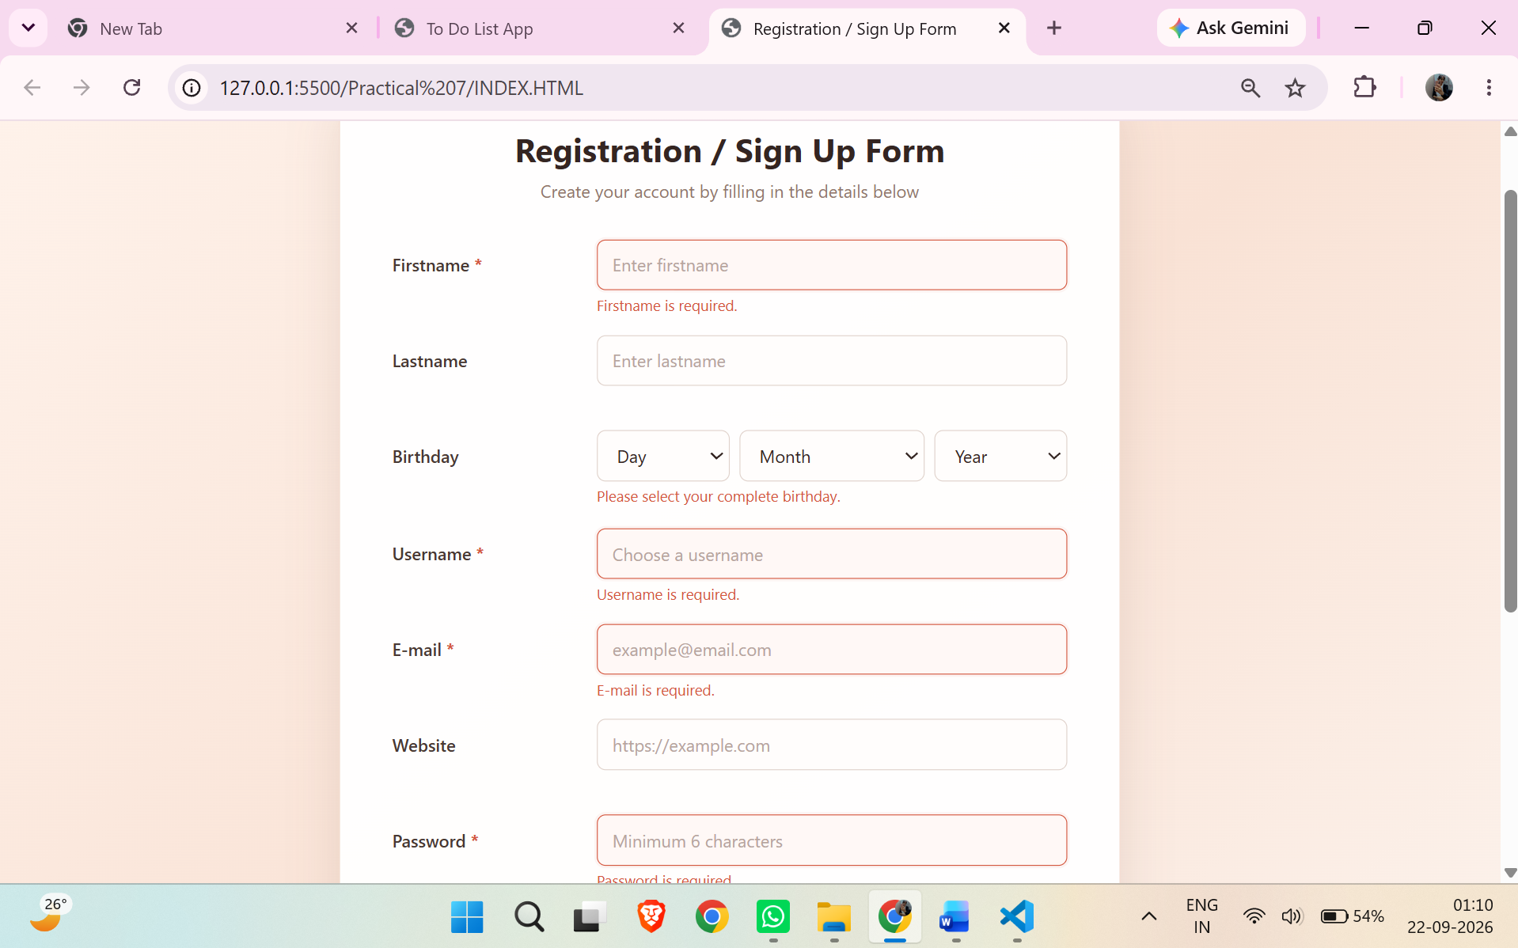
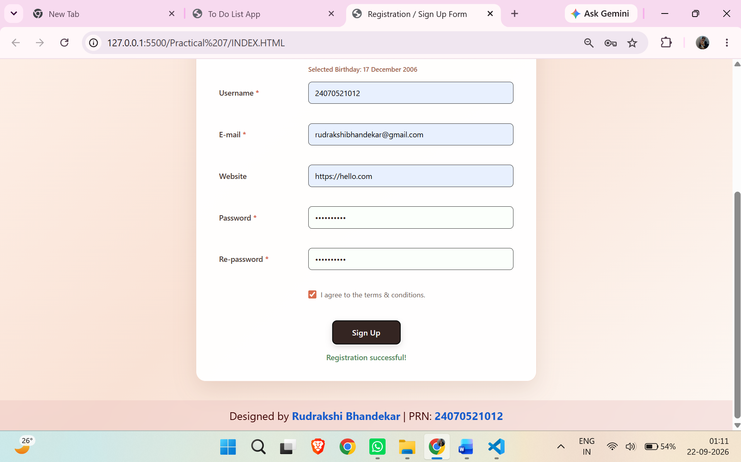
Conclusion –
The experiment was successfully performed to understand DOM traversal, manipulation, event handling, and form validation using JavaScript. A To-Do List application with Add, Edit, and Delete features was developed, and a registration form was implemented with dynamic validation and error handling.

